# ECON 1000 – Contemporary Economic Issues “Market Failure and the Allocation Function of Government”

**Relevant Readings from the Required Textbooks:**

* Chapter 10, *Market Failure*

**Definitions and Concepts:**

* Three primary functions of government in the economy: allocation function, distribution function, and stabilization function
* **allocation function** – government production of goods or regulation of business, aimed at improving the allocative efficiency of the economy (i.e., getting the “right mix” of products produced, each in the “ideal quantity” and at the “ideal quality”).
* **distribution function** – government policies aimed at changing the final distribution of goods/services across consumers, usually with the intention of realizing a “fairer” apportionment of consumption/income/wealth.
* **stabilization function** – attempts by government to minimize fluctuations in overall macroeconomic activity.
* **market failure** – a situation in which the “free market outcome” is inefficient, in that there is a positive Deadweight-Loss at the resulting “free market level of trade.”
* **four common sources of market failure:** (1) profit maximization by a firm with market power, (2) market provision of public goods, (3) market provision of goods generating externalities, and (4) lack of information by market participants
* **market power** – A firm has market power if they have some “control over the price of their output,” in that they: (i) can increase price without losing all customers and (ii) must decrease price in order to increase sales
* **monopoly** – market structure in which there is one single seller of a unique good with no close substitutes.
  + The “polar opposite” of “perfect competition.”
  + The demand curve facing a monopolist is the market demand curve.
  + They can choose any price/quantity combination along the market demand curve.
* **profit** – the difference between revenues and costs of production
* **marginal revenue** – the amount by which revenue changes as the firm’s quantity of output is increased by a unit
* **marginal costs of production** – the amount by which production costs change as the firm’s quantity of output is increased by a unit
* **non-rival good** – a good for which consumption by one person does not diminish the quantity or quality of consumption by others
* **rival good** – a good for which consumption by one person does diminish the quantity or quality of consumption by others
* **non-excludable good** – a good for which it is difficult (or very costly) to prevent consumption by those who do not pay
* **excludable good** – a good for which it is easy to prevent consumption by those who do not pay
* **private good** – a good that is excludable and rival in consumption.
  + e.g., Big Mac from McDonald’s; market provision is typically efficient
* **public good** – a good that is non-excludable and non-rival in consumption

▪ e.g., national defense

* **club good** – a good that is excludable and non-rival in consumption
  + e.g., satellite radio or television broadcast
* **common good** – a good that is non-excludable and rival in consumption
  + e.g., stock of fish in the ocean
* **free rider problem** – if a public good were supplied in a free market, the amount traded would be less than the efficient quantity, since many people would attempt to enjoy the benefits of units purchased by others, while not purchasing any units themselves
* **externality** – a benefit or cost that is realized by someone who is not directly engaging in an activity
* **negative externality** – a cost of an activity borne by someone not engaging in the activity.
  + examples: pollution, noise from low-flying aircraft, speeding on a highway, installation of “The Club” in a car
* **positive externality** – a benefit from an activity realized by someone not engaging in the activity
  + examples: vaccines, installation of smoke detector in an “attached apartment,” installation of Lojack in a car
* Market provision of a good for which there is an externality is inefficient:
  + Negative externality => free markets provide more than the optimal amount (i.e., too much) of the good
  + Positive externality => free markets provide less than the optimal amount (i.e., not enough) of the good
* Potential policies to reduce the DWL associated with a “negative externality”
  1. ban the activity entirely (“illegal to emit any pollution”)
  2. establish minimum compliance standards for manufacturers (“can only pollute up to a certain level”)
  3. “cap and trade” – issue a certain number of “pollution permits” for society as a whole, and allow people to trade these permits amongst themselves
  4. offer subsidies to manufacturers that reduce pollution (“pay the polluter to reduce their level of pollution”)
  5. charge manufacturers a fee for each unit of pollution emitted (“polluter must pay for the right to pollute”)
* **internalizing an externality** – policies which introduce a cost (or foregone gain) that is realized if the person continues to generate a negative externality
* **Coasian solution to the problem of externalities** – Ronald Coase (1910-2013; Noble Prize in 1991; Professor Emeritus at Univ. of Chicago Law School) argued that problems of externalities are at their core due to undefined property rights and can be address by the following approach:
  + 1. clearly and fully define property rights
    2. make individuals pay compensation if they infringe upon the property rights of others
    3. allow parties to negotiate with one another regarding infringements on property rights caused by the externality
  + Coase showed that regardless of which party is given the property right, negotiation between the parties will result in the efficient level of the externality (so long as the costs of negotiation and enforcement are low enough)
  + defining property rights and allowing parties to negotiate essentially “***internalizes the externality***”
* **market failure due to lack of information** – for some goods consumers may have difficulty knowing their “true reservation price” => especially common for goods purchased infrequently or for which quality is difficult to observe (e.g., house, car, education, medical procedure, meal at a restaurant)
  + when consumers lack accurate information about costs or benefits of consuming a good, they may fail to make efficient choices in the marketplace
  + Further note, “information” is often a “club good” (non-rival in consumption and excludable).
* Once a club good is produced, the additional cost of providing it to the next person is essentially zero => to maximize social surplus, everyone who has a positive value for the information should be able to access it
* Additionally, as long as the information is accurate, total costs to society are minimized if the information is only generated once (e.g., it is a waste of resources to have both the National Weather Service and AccuWeather come up with weather forecasts)
* In such cases, have government license, inspect, and/or regulate providers of such goods in order to:
  + 1. provide people with the important information needed to make good decisions in markets and
    2. minimize the costs to society of providing the information
* e.g., “Cobb and Douglas Public Health” inspects restaurants and assigns letter grades based upon compliance with health codes => government “regulates product” and “provides information”

**MULTIPLE CHOICE QUESTIONS**

1. “Market Failure” can be described as a situation in which
   1. a situation in which Total Social Surplus is decreased by government intervention in a market
   2. the “free market outcome” is NOT efficient.
   3. government intervention leads to a greater Deadweight-Loss than does the “free market outcome.”
   4. government imposes progressive taxes, in order to indirectly redistribute income.
2. Which of the following is a common source of “Market Failure”?

A. Pricing by firms with market power.

* 1. Market provision of private goods.
  2. Market provision of a good which generates an externality.
  3. More than one (perhaps all) of the above answers are correct.

1. A good is “Excludable” if
   1. consumption by one person does not diminish the quantity/quality of consumption by others.
   2. consumption by one person does diminish the quantity/quality of consumption by others.
   3. it is difficult (or very costly) to prevent consumption by those who do not pay for the good.
   4. it is easy (or relatively costless) to prevent consumption by those who do not pay for the good.
2. A firm operating in a “Perfectly Competitive Market” has “No Market Power,” which implies that the firm
   1. would lose all its customers if it attempted to increase price above the prevailing market price.
   2. must decrease its price in order to increase the quantity of output sold.
   3. faces a “horizontal demand curve” for its output.

D. More than one (perhaps all) of the above answers is correct.

1. On September 11, 2010, current Heavyweight Champion Wladimir Klitschko defeated Samuel Peter by knockout in Frankfurt, Germany. This fight was only available in the U.S. on “Pay Per View.” The broadcast of this bout on “Pay Per View” is excludable but non-rival, and was therefore a

A. Public Good.

* 1. Private Good.
  2. Club Good.
  3. Common Good.

1. Which of the following policies could likely reduce “Deadweight-Loss” in the presence of a negative externality, such as pollution?
   1. Establish minimum compliance standards for manufacturers in the industry (allowing them to generate only a certain amount of the negative externality).
   2. Do nothing (i.e., just let the market allocate the good as is currently the case, with no deliberate government action whatsoever).
   3. Offer subsidies to manufacturers for reducing the amount of the negative externality that they generate.
   4. More than one (perhaps all) of the above answers is correct
2. A government policy that attempts to “Internalize an Externality” can be generally described as
   1. a policy which completely bans an activity that generates an externality.
   2. a policy which introduces a cost (or foregone gain) that would be realized by a decision maker who generates an externality.
   3. a policy which mandates the exact level of an activity that decision makers must engage in.
   4. None of the above answers are correct.

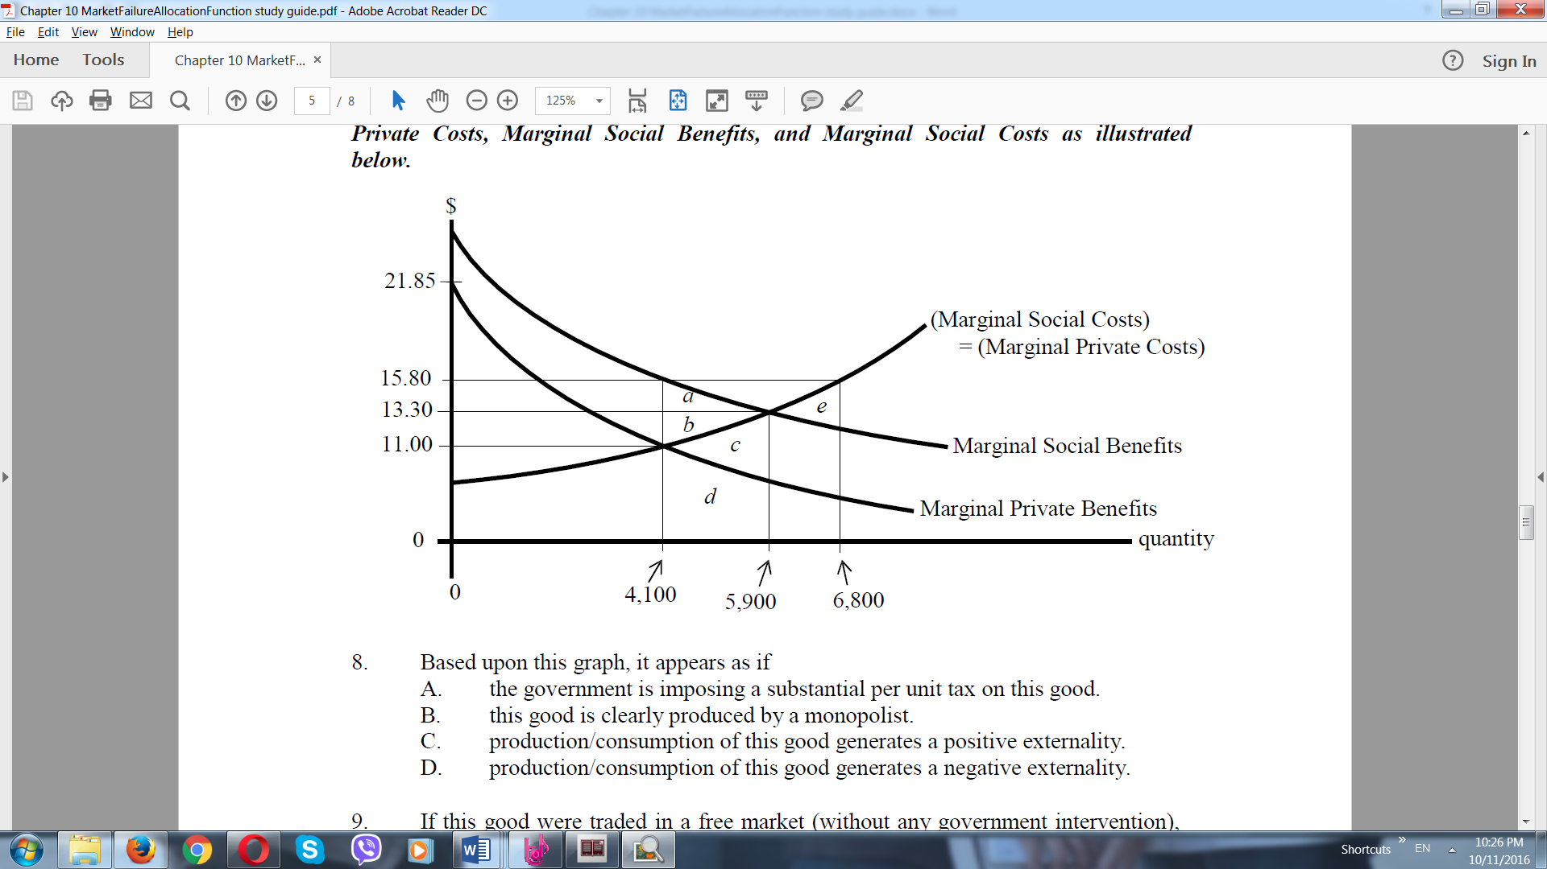***For Questions 8 through 10, consider a good with Marginal Private Benefits, Marginal Private Costs, Marginal Social Benefits, and Marginal Social Costs as illustrated below.***

1. Based upon this graph, it appears as if
   1. the government is imposing a substantial per unit tax on this good.
   2. this good is clearly produced by a monopolist.
   3. production/consumption of this good generates a positive externality.
   4. production/consumption of this good generates a negative externality.
2. If this good were traded in a free market (without any government intervention), , although the Social Welfare Maximizing level of trade is .

A. 6,800 units would be traded; 5,900 units.

* 1. 5,900 units would be traded; 4,100 units.
  2. 4,100 units would be traded; 5,900 units.
  3. 0 units would be traded; 6,800 units.

1. At the free market outcome (without any government intervention) there would be a Deadweight-Loss equal to
   1. “area (c).”
   2. “area (e).”
   3. “areas (a)+(b).”
   4. “areas (a)+(b)+(c).”
2. In the presence of a “negative externality,” the free market would

A. provide more than the efficient amount of the good.

* 1. provide less than the efficient amount of the good.
  2. have trade take place at a price of $0.
  3. None of the above answers are correct.

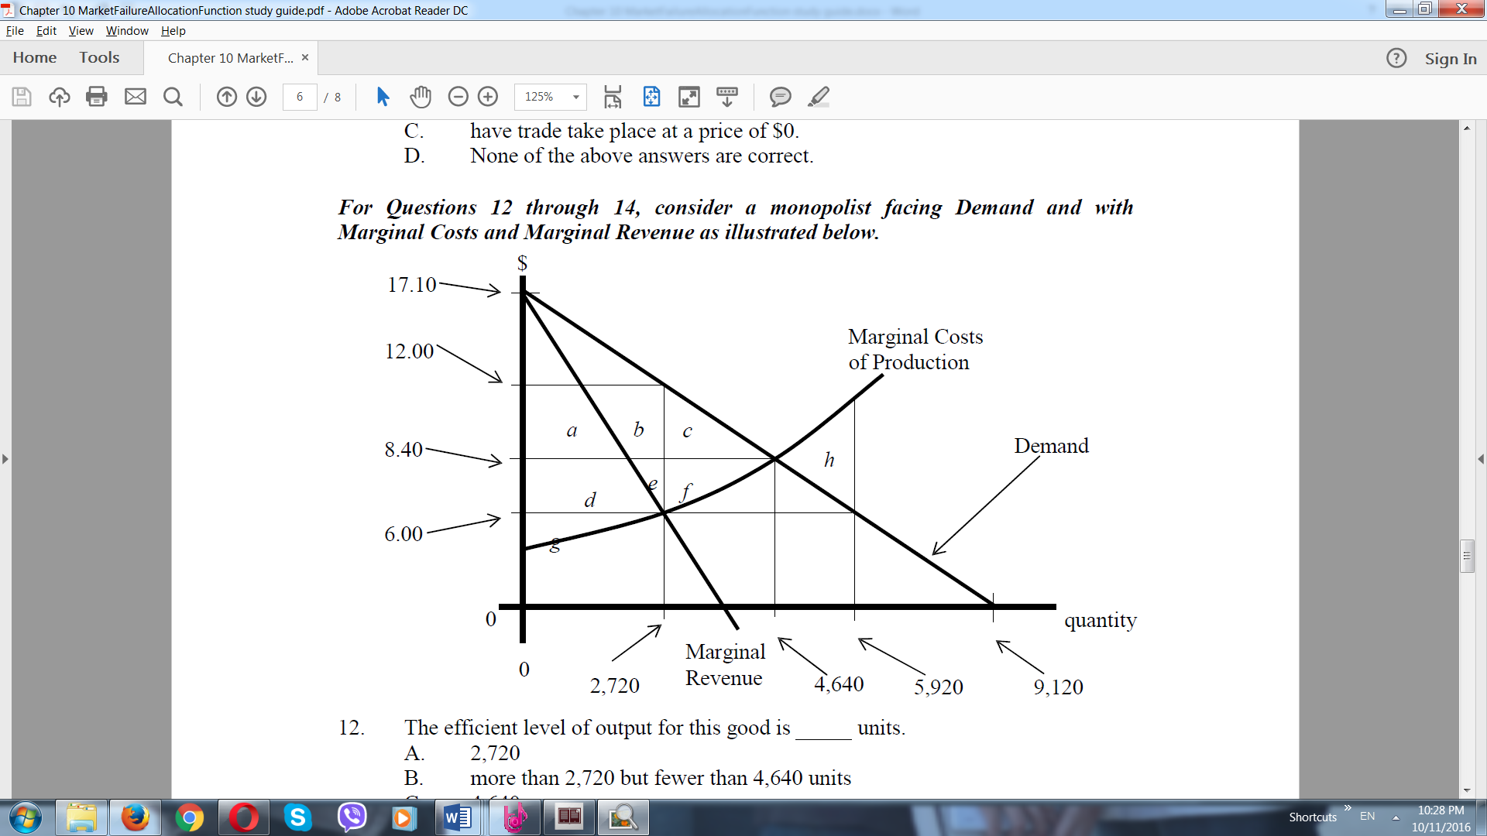***For Questions 12 through 14, consider a monopolist facing Demand and with*** ***Marginal Costs and Marginal Revenue as illustrated below.***

1. The efficient level of output for this good is units.
   1. 2,720
   2. more than 2,720 but fewer than 4,640 units
   3. 4,640
   4. 9,120
2. To maximize profit, this monopolist would
   1. sell 9,120 units of output, each at a price of $17.10.
   2. sell 4,640 units of output, each at a price of $8.40.
   3. sell 2,720 units of output, each at a price of $12.00.
   4. None of the above answers are correct.
3. When this monopolist chooses the price and quantity which maximizes profit,
   1. Deadweight-Loss is equal to “areas (n)
   2. Producer’s Surplus (i.e., “Monopoly Surplus”) is equal to “areas (a)+(b)+(d)+(e)+(g).”
   3. Deadweight-Loss is equal to “areas (c)+(f).”
   4. More than one (perhaps all) of the above answers is correct.
4. If a person drives less carefully after obtaining car insurance,

A. that person is feeling buyer's remorse.

* 1. the reason is adverse selection.
  2. there are no information costs.
  3. a moral hazard exists.

1. Mary is trying to sell a high-quality television set; however, none of the potential buyers is willing to pay the price Mary desires. Mary's friend Sue, an economist, thinks this might be due to a lack of information on the part of buyers. Sue uses the concept of to explain to Mary why she cannot sell her TV at the price she is asking.
   1. supply and demand
   2. adverse selection
   3. moral hazard
   4. None of the above answers are correct.
2. When driving your car, you impose external costs on others, because they must now breathe air that contains your car exhaust. Driving causes such negative externalities because
   1. drivers always pay the full costs of their actions.
   2. drivers are responsible for compensating victims for any external costs.
   3. no one owns the air space in which the emissions occur.
   4. others are envious that they can't drive the same type of car.
3. Government often intervenes in economic choices through

A. speed limits and traffic laws.

* 1. requiring the listing of ingredients on packaged food.
  2. providing public education.
  3. All of the above

1. Education is a good example of a positive externality because the benefits of an education accrue not only to the individual but also to society as a whole.
   1. True
   2. False
2. An unregulated market is likely to produce too much of a good, compared with the socially efficient output, when
   1. negative externalities exist.
   2. all costs and benefits of production and consumption are reflected in the price of the product.
   3. positive externalities exist.
   4. benefits accrue to individuals not directly involved in the transaction.

**Answers to Multiple Choice Questions:**

1. B
2. D
3. D
4. D
5. C
6. D
7. B
8. C
9. C
10. C
11. A
12. C
13. C
14. D
15. D
16. B
17. C
18. D
19. A
20. A